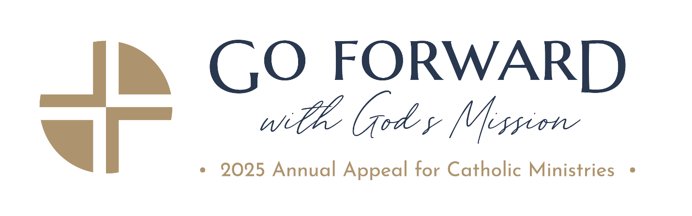

Date

Addressee
Address 1
City, State Zip

Dear Salutation,

Thank you for your generous gift of $gift amount to the 2025 Annual Appeal for Catholic Ministries. In keeping with the theme of this year’s Appeal, Go Forward with God’s Mission, you have responded without hesitation by embracing the journey ahead with courage, and trust in God’s mission. It is a reminder that our faith is not static, it is a living and dynamic force propelling us to action, to serve others, and to share the Good News with all.

Your contribution to the Annual Appeal makes a genuine impact on the lives of those in need, helping to sustain more than 100 life-affirming ministries across our Archdiocese. Importantly it also directly enhances our own parish community too.

This year, our parish’s Appeal goal is $goal amount. It is my hope and prayer that we can exceed this target, accurately reflecting our commitment to both our parish and the broader Church community. On behalf of parish name, the Archdiocese of Baltimore, and all who will benefit from your Christ-like kindness, please allow me to extend again my utmost thanks for your support.

Your generosity and commitment to becoming a steward on behalf of those we serve is a valuable example for us all.

In the Lord,

Pastor Name

