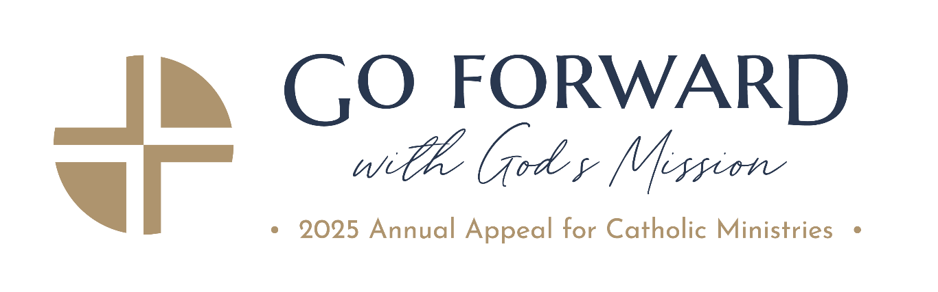

2025 Annual Appeal for Catholic Ministries
Frequently Asked Questions:
- Will my gift to the Annual Appeal for Catholic Ministries be used to pay legal settlements?
No. Gifts are made to the Annual Appeal to support specific ministries and programs, and those funds will be used for those purposes only. Since 1992, your generosity has enabled over 100 life-affirming ministries to transform lives, a testament to our shared commitment to making a difference. Rest assured, your contributions to the Annual Appeal are securely managed as part of a separate, perpetual, and irrevocable trust established in 1992, exclusively used for these vital ministries and restricted from being used for any other purposes.

- Will the Parish Dashboards be updated with the 2025 numbers?
Yes, parish dashboards, as well as the website progress report, will be updated shortly to reflect the 2025 goals and year-to-date results. The parish dashboards show real-time results, and the progress report will be updated on a regular basis (weekly, bi-weekly).

- Are there Spanish materials available?
Yes, Spanish materials are available on the Parish Resource page on the AOB website, and most Appeal materials are bilingual.
https://www.archbalt.org/_parishes/

- How much of the Appeal money raised goes back to the parishes?
Approximately 23% of the dollars raised during the Appeal are returned to the parishes. Parishes that reach their goals receive rebates at a higher percentage rate for all money raised above goal. These funds may be used for any parish project, program, or need at the discretion of the pastor.

- Who do we contact to request a guest speaker/ambassador?
Please contact your Regional Director (Kim Montgomery or Mark Talcott) if you would like a speaker at your Masses. Please let us know as soon as possible so we can make arrangements.

- Do Appeal dollars pay salaries?
Funds raised from the Annual Appeal for Catholic Ministries support archdiocesan programs and ministries for the current year, including the salaries for staff working within those ministries.

- Who decides what ministries are supported?
Each year, an Allocations Committee consisting of pastors, lay leaders, and archdiocesan employees meets and distributes the Appeal dollars to the ministries supported. Information on many of the Appeal’s beneficiaries is located on the Appeal website here: https://www.archbalt.org/campaign-priorities/. Financial documents with a detailed breakdown of the Archdiocese of Baltimore’s budget may be reviewed here: https://www.archbalt.org/the-archdiocese/fiscal-accountability/.

- How are the Parish Goals set?
The goal structure will remain the same as 2025 with two goals provided to each parish:
- Standard – 9% of Offertory
- Stretch – 12% of offertory.
These goals are set based on the 2023 offertory totals.
Appeal rebates to parishes will remain the same.
- 10% of the total amount raised up to the standard goal.
- 40% of the amount raised above the standard goal but below the stretch goal.
- 75% of the amount raised above the stretch goal.
Limited funds are available for the school tuition assistance match. To participate, please note the percentage of your parish share allocated to the match on your parish data sheet.

- Seek the City to Come Parishes – How were the Seek the City parish goals calculated?
The goals were calculated by adding 80% of the merged parishes’ goals to the seated parishes’ goals. This is a “test year” and we will reevaluate the goals for the 2026 Annual Appeal, based on the 2025 results.

